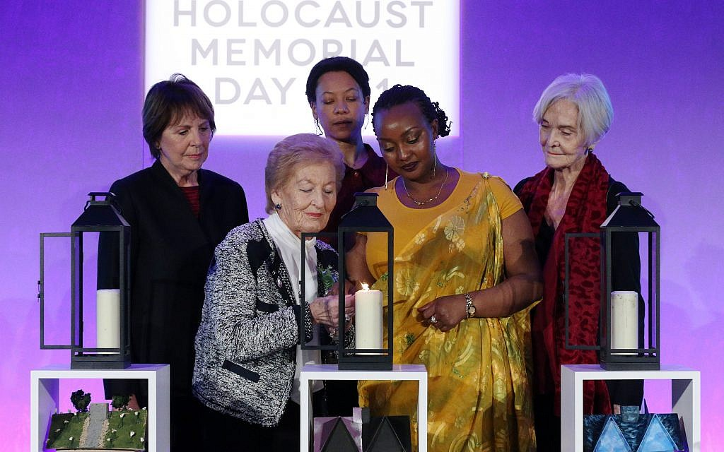
Actors (back row left to right) Dame Penelope Wilton, Nina Sosanya and Sheila Hancock join Holocaust survivor Mindu Hornick (front left) and Rwandan genocide survivor Chantal Uwamahoro (front right) in lighting a candle in memory of all victims of genocide at a Holocaust Memorial Day ceremony held the QEII Centre, Westminster, London. Photo credit: Jonathan Brady/PA Wire
Senior politicians and community leaders joined 200 survivors of the Holocaust and genocides to honour the millions of people who were murdered.
Britain’s Jewish community was assured it was an “intrinsic part of what makes Britain great”, at a national memorial service in Westminster.
Chair of the Holocaust Memorial Day Trust Laura Marks told guests trustees had been questioned over recent months about whether the guest list was “appropriate” given the reported prevalence of anti-Semitism within mainstream politics.
She told the room: “We were asked if it was appropriate to continue to welcome some representatives knowing that this may cause distress to Holocaust survivors and refugees.
“But we know through independent studies that people who attend Holocaust Memorial Day events learn more, empathise more deeply and go on to do more to build a better future.”
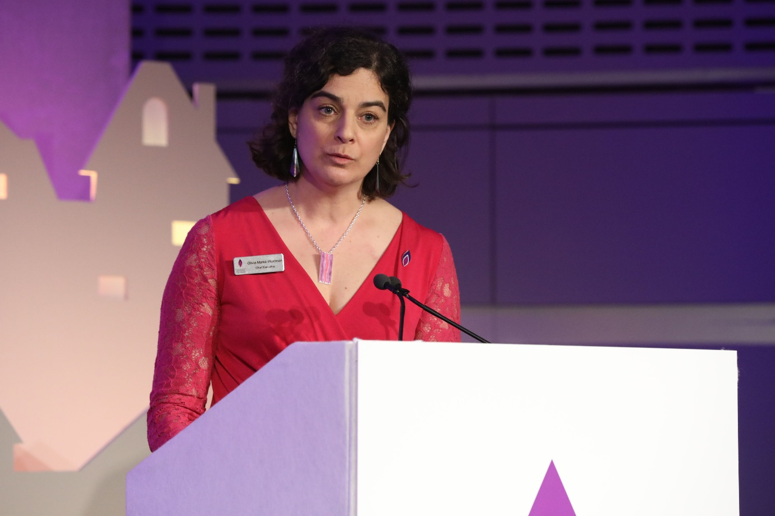
Holocaust Memorial Day Trust Chief Executive, Olivia Marks-Woldman, speaking the event to mark HMD 2019. Photo credit: Justin Grainge/Holocaust Memorial Day Trust/PA Wire
Labour leader Jeremy Corbyn arrived 20 minutes before the service began and was seen chatting and taking photos with guests.
He earlier posted on Twitter: “Let us never allow anti-Semitism or any other form of racism to disfigure our society.”
The Labour leader said afterwards that he found the ceremony “deeply moving”, calling it “a powerful reminder of why we must stand against racism and oppression everywhere”.
Speaking to about one thousand guests, Communities Secretary James Brokenshire said he was “deeply” troubled by the prevalence of modern-day prejudice.
He said: “We still imagine that these barbarities belongs in the history books, and yet today, 74 years since the Nazi death camps were liberated, anti-Semitism is on the rise, here and abroad, and Jewish communities are once again living in fear.
“This troubles me deeply and must trouble us all.
“And I want to reassure our Jewish community that you are an intrinsic part of what makes Britain great, and the Government will always stand by you to challenge bigotry and intolerance and reaffirm our commitment to ensuring that future generations never forget where hatred can lead.”
Ahead of the ceremony, special envoy for post-Holocaust issues Lord Eric Pickles told survivors at a reception that “democracy is the best bastion against tyranny”.
He said: “The battle of the Holocaust continues to this day.
“There are serious numbers of people that want to pretend it didn’t exist.
“There are serious numbers of people that want to lie about the Holocaust.
“And we are here to counter that with truth.”
TV actors Nina Sosanya and Sanjeev Bhaskar both gave readings during the service, which was interspersed with poignant short films from survivors and musical tributes.
London Mayor Sadiq Khan, Home Secretary Sajid Javid, Metropolitan Police Commissioner Cressida Dick and Chief Rabbi Ephraim Mirvis were also present.
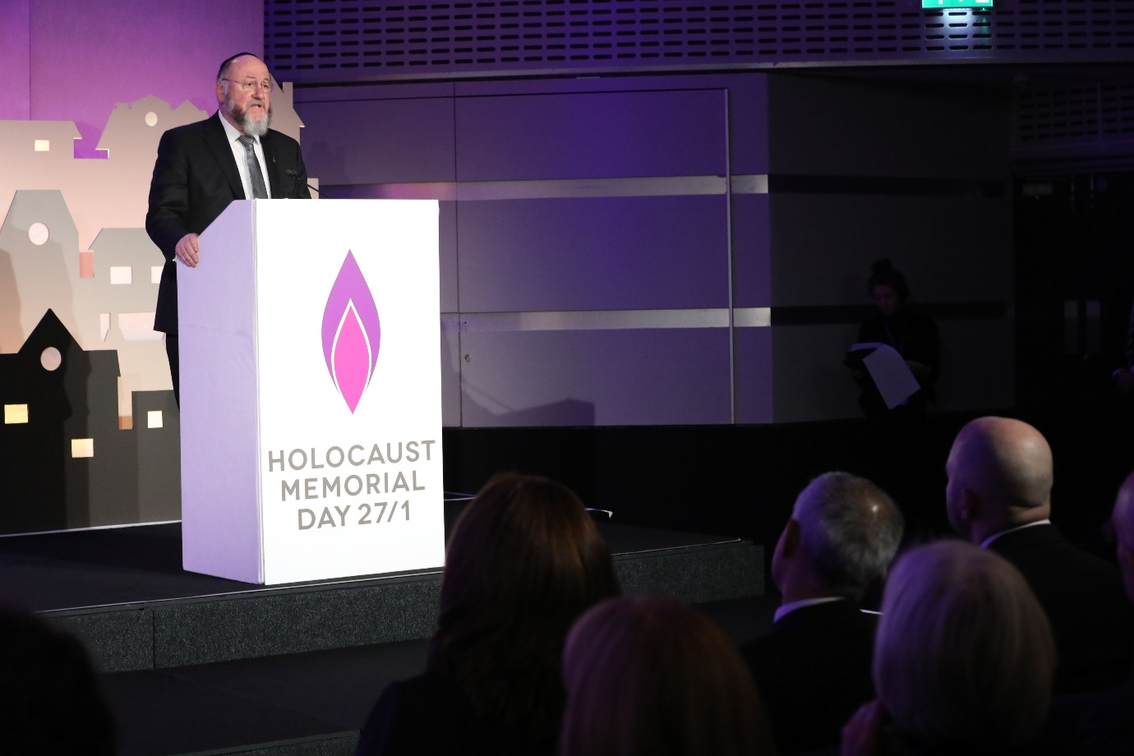
Chief Rabbi Ephraim Mirvis speaking at an event at the QEII Centre in central London to mark Holocaust Memorial Day. Photo credit: Justin Grainge/Holocaust Memorial Day Trust/PA Wire
Six candles were lit by survivors, including grandmother Rachel Levy, to represent the six million Jewish victims of the Holocaust and those who died in more recent genocides.
Ms Levy, who survived Auschwitz concentration camp in Nazi-occupied Poland as a teenager with her brother, said she found the current level of anti-Semitism in Britain “frightening”.
The 87-year-old, who was born in former Czechoslovakia and came to the UK after the war, said: “It’s worrying and frightening, because I can’t believe that things can happen again.
“And one shouldn’t close one’s eyes to that, close your hearing for that because it is happening, people are turning nasty again, of all classes.
“I don’t understand why.

“People I meet are normal people, I have not suffered from it myself, I haven’t come across any aggressive people, but it’s happening to other people and it’s visible.
“It’s visible by the mere fact that we can’t advertise where we are (here today) we can’t do things like that, we don’t put ourselves forward.
“I’m Jewish, so what? We don’t deny it, but we don’t boast about it.
“I love being Jewish and I’ll never give it up and I’m not religious….but I still believe that miracles have happened to me and there is hope.”
The ceremony ended with Somewhere Over the Rainbow sung by the Fourth Choir.
It comes as a survey commissioned by the Holocaust Memorial Day Trust found that one in 20 UK adults does not believe the Holocaust took place, while one in 12 believes its scale has been exaggerated.
Almost two-thirds of respondents (64%) either could not say how many Jews were murdered or “grossly” under-estimated the number, the survey of more than 2,000 people found.

